Chapter 3 Geomorphological Framework Version 6 December 2012

D. P Giles¹ & J.S. Griffiths²

¹School of Earth & Environmental Sciences, University of Portsmouth, Portsmouth, PO1 3QL

²School of Geography, Earth & Environmental Sciences, University of Plymouth, Plymouth, PL4 8AA

- Geomorphological Framework

  - Abstract

  - Introduction

  - Terrain Evaluation

  - Terrain Classification

  - Ground Models

    - Geomorphological Process-Response Systems
      - Generalised Overall Glacial Process-Response Systems and Ground Models
      - Generalised Glacial Sediment Deposition Process-Response Systems and Ground Models

    - Active Periglacial Landscapes

    - Relict periglacial landscapes

    - Deglaciated and relict glacial and periglacial landscapes

  - Terrain Unit Descriptors
    - Terrestrial Glacial Environment
      - Definition
      - Key Landforms and Features
Aerial Scouring
Glaciated Valleys
Hanging Valley
Arêtes
Watershed Breach
Whaleback
Trough Head
Rock Step
Cirque
Col
Horn
Nunatak
Groove
P Forms
Striations
Polished Surfaces
Roche Moutonnee
Riegel
Lunate Fracture
Crescentric Gouge
Crecsentric Fracture
Chattermark
Moraines
Lateral Moraine
Medial Moraine
Shear / Thrust Moraine
Recessional Moraine
Annual Push and Squeeze Moraine
Fluted Moraine
Hummocky Ground Moraine
Cover Moraine
Terminal Moraine
Moraine Dump Moraine
De Geer (Washboard) Moraine
Rogen (Ribbed) Moraine
Ground Moraine
Hummocky or Dead Ice Moraine
Kame Moraine
Ice Cored Moraine
Rockfall
Dirt Cone
Erratic
Crevasse Filing
Drumlin
Drumlinoid Ridge
Crag and Tail Ridge
Till Plain
Gentle Hill
Debris Flow
Trimlines
Glacial tectonic
Foliations
Lineations
Boudinage
Shear Zones
Folds
Faults
Thrusts
Graben and Half Graben
Rafts
Rinnen (G or FG?)
Nye Channels (G or FG?)
Rothlisberger Channels (G or FG?)

Key Deposits (Brief overview – depth and detail in later chapters)
Tills
Glaciolacustrine Sediments
Glaciofluvial Sediments
Moraine

  - Fluvial Glacial Glaciofluvial Environment
    - Definition
    - Key Landforms
Tunnel Valley
Subglacial Gorge
Nye Channel
Megaflutes
Esker
Kames
Kame
Kame Field
Kame Plateau
Kame Terrace
Kame Delta
Outwash Plain (Sandar)
Valley Train
Outwash Fan
Pitted Plain
Outwash Delta Complex
Kettle Hole / Pond
Glacial overflow and marginal channels
Ice Margin (Lateral) Meltwater Channel

    - Key Deposits (Brief overview – depth and detail in later chapters)
Proximal
Medial
Distal

  - Lacustrine Glacial Glaciolacustrine Environment
    - Definition
    - Key Landforms and Features
Deltas
Delta Moraines
De Geer Moraines
Shorelines or Strandlines

    - Key Deposits (Brief overview – depth and detail in later chapters)
Deltaic Sediments
Lake Bottom Sediments
Meltout Sediments

  - Marine Glacial Glaciomarine Environment
    - Definition
    - Key Landforms and Features
Fjord
Flutes
Moraine Banks
Grounding Line Fans
Ice Contact Deltas
Fluviodeltaic Complexes
Till Delta
Submarine Troughs
Tunnel Valleys
Ice Berg and Sea Ice Scours
Slope Valleys
Boulder Pavements
Flutes
Transverse Ridges
Shelf Moraines

  - Key Deposits (Brief overview – depth and detail in later chapters)
Proglacial Laminites
Fjord Bottom Sediment Complexes
Beach and Tidal Flat Features
Iceberg Turbate Deposits
Quick Clays

  - Periglacial Environment
    - Definition
    - Key Landforms and Features
Frost Creep
Frost stirring & sorting
Involutions
Sorted Stone Circles
Relict Large Scale Thermokarst Depressions
Periglacial landslides and rockfalls
Solifluction Landforms
Lobes
Benches
Sheets
Periglacially induced shears
Relict Frost Mounds / Relict Ramparted Ground-Ice Depressions
Pingos
Open system
Closed system
Palsas
Lithalsas
Anomalous depressions beneath river terraces
Glacio-eustatic / isostatic effects
Buried valleys
Sub seal level caves
Reactivation of coastal landslides
Leaching of former marine sediments
Intra plate faulting & earthquakes
Glacial overflow and marginal channels
Ice and Soil Wedges
Ice Wedge Polygons
Protalus rampart
Cryoplanation terrace
Blockfields/felsenmeer
Nivation hollow
Tors
Superficial valley disturbances
Cambering
Dip and Fault structures
Gulls

    - Key Deposits (Brief overview – depth and detail in later chapters)
Periglacial solifluction
Granular materials
Clayey materials
Aeolian deposits

  - Acknowledgements

- Geomorphological Framework

3.3 Terrain Evaluation

Terrain Evaluation encompasses range of geomorphological techniques, as identified by Lawrance et al (1993). They described it as a method for summarizing the physical aspects of a landscape initially through classification and then undertaking an assessment of ground conditions which can be expressed in terms of engineering requirements. Griffiths & Edwards (2001) took a similar definition, although had a preference for the expression ‘Land Surface’ rather than ‘Terrain’ evaluation but the terms can be regarded as synonymous. Griffiths & Edwards (2001) stated that it is the evaluation and interpretation of land surface and near surface features using techniques that do not involve ground exploration by excavation (NB except using small hand-dug pits or hand auger holes) or geophysics. Based on this definition terrain evaluation can be regarded as integral to the development of the ground model (Fookes, 1997) which is central to all successful civil engineering construction.

The range of techniques that might be employed in terrain evaluation include: geomorphological mapping, geological mapping, engineering geological mapping, remote sensing interpretation, analytical photogrammetry, land systems mapping, natural hazard and risk assessment, and the use of Geographical Information Systems (GIS). The output from a terrain evaluation is usually a suite of maps and block diagrams either held as hardcopy or as a series of overlays in a GIS. The map data can be classified into three categories (Griffiths, 2004):

- Element maps that record the actual measurable and/or mapped ground conditions (i.e. the factual basis such as: topography; bedrock geology; morphology; land use; location of previous site investigations etc).

- Derivative maps and diagrams obtained by either combining various element maps or based on an interpretation of the element maps (e.g.: geomorphology based on an interpretation of the morphology; slope steepness derived from the topographic data; depth to bedrock compiled by combing ground investigation data, superficial deposit and bedrock maps; block diagrams showing the landscape and sub-surface geology in three dimensions).

- Summary maps and diagrams the pull together a range of derivative and element maps to identify combinations of hazards, resources or land use issues that act either as constraints to any development or indicate the potential of the land for exploitation.
An extended legend would normally be attached to each of the maps and diagrams or linked to GIS layers and terrain evaluation studies would of necessity include an interpretative report that explains the basis for the development of the derivative and summary maps. This methodology is appropriate for use in all environments. The techniques are specifically identified as required for engineering geological investigations in hot deserts (Shilston et al, 2012) and mountain roads (Hearn, 2011). In these papers the use of a range of terrain evaluation techniques is described on a number of case studies. Examples of the use of a terrain evaluation approach on engineering projects associated with U.K relict glacial and periglacial conditions are very limited perhaps because the process would be deemed to be part of normal ground model development during the interpretation of a site investigation. Waller & Phipps’ (1996) study of relict periglacial condition along the alignment of the Channel Tunnel Link is one of the few that specifically refers to terrain systems mapping (see below). Notwithstanding this, it is clear that the terrain evaluation approach has widespread acceptance in engineering geology as a technique for reconnaissance investigations. The way the techniques of terrain evaluation feds into the creation of the various forms of ground model for engineering projects (Fookes, 1997) through terrain classification and the creation of land systems is explored below.

3.3.1 Terrain Classification

Terrain evaluation as an approach to investigation for engineering covers a range of techniques, whilst terrain classification is a quite explicit process. Lawrance et al, (1993) indicate that the expression is normally used for the process of subdividing a landscape into land systems, land facets and land elements. Christian and Stewart (1953), from their work with the Commonwealth Scientific and Industrial Research Organisation (CSIRO) in Australia produced the following definition for the land system:

“The topography and soils are dependent on the nature of the underlying rocks (i.e. geology), the erosional and depositional processes that have produced the present topography (i.e. geomorphology), and the climate under which these processes have operated. Thus the land system is a scientific classification of country based on topography, soils and vegetation correlated with geology, geomorphology and climate.” (Page 53)

Finlayson, (1984) uses slightly different terminology to describe the PUCE system of terrain analysis further developed by CSIRO in Australia, with a very broad scale landscape province, identified on maps at 1:250,000, being subdivided into terrain patterns, terrain units and terrain components (Figure 3.1). Examination of the PUCE system demonstrates that terrain patterns are equivalent to land systems, units to facets, and components to elements. In this chapter the intention will be to adopt the land systems terminology with definitions as follows:

Land System- This is a large area (e.g. 100 km²) with a recurring pattern of landforms, soils, vegetation, geology and hydrological regimes (Christian and Stewart, 1953; Mitchell, 1973; Lawrance et al, 1993). Normally land systems will be mapped at small scales, e.g. >1:100,000

Land Facet–This is a terrain unit of uniform slope, parent material, soils and hydrological conditions. Lawrance et al (1993) describe it as “sufficiently homogenous to be considered uniform for most practical purposes”. Land facets combine to make up a land system and can be mapped at scales ranging between 1:10,000 and 1:100,000. Land facets can often be given simple morphographic descriptors such as pyramidal peak, outwash plain, drumlin etc.

Land Element–This is the smallest unit of the classification and will be combined to make a land facet. These could include simple morphological descriptors such: concave slope; cliff, convex slope.

Lawrance et al (1993) did suggest that in practice there is very little difference between a geomorphological map (see Brunsden et al 1976; Smith et al 2011), a geotechnical map (see Clark and Johnson, 1976; Griffiths et al 1994) and a land system/land facet map. This would be true for the type of map prepared by Waller & Phipps (1996) for the channel tunnel link discussed above. However, geomorphological maps would be expected to record actual conditions at specific sites, including information on landform genesis, whereas a land systems map would normally establish recurrent landscape themes that are presented as a generic three dimensional model rather than representing one particular locality.

3.3.2 Ground Models

A key component of terrain evaluation for engineering purposes is to develop an understanding of the ground conditions. Increasingly in the engineering geological literature this is being expressed in terms of creating ground models (Fookes, 1997). IAEG Commission 25 identifies three types of engineering geological model (Parry 2012), conceptual, observational and analytical. It is recommended that this terminology is used as a basis for this Working Party Report. These three categories of model have been subdivided in table 3.1 to cover the range of models that have been encountered in the engineering geology literature on glacial and periglacial conditions.

Table 3.1 Ground Models

Figure 3.1 Terrain Classification System (from Phipps, 2001)

3.3.3 Geomorphological Process-Response Systems

Because engineering geology and geomorphology in the UK have developed independently there are inconsistencies between the terminologies that are used in the two disciplines. One critical difference appears to be in the use of the term ‘land systems’. For engineering geologists this is the component of terrain classification, as described above. However, geomorphologists (e.g. Addison 1983;Evans 2011) use the expression ‘landsystems’ to describe geomorphological processes and landforms in specific and generic situations. The history and use of the term ‘systems’ in geomorphology has very helpfully been reviewed by Huggett (2007) which helps bring some clarity to the situation. The geomorphologist’s ‘land systems’ would fit within the engineering geologist’s definition of ‘ground models’ (section 3.3.2). To avoid confusion in this WP Report the term “process-response systems” is used to describe these geomorphological models and distinguish them from the terrain classification approach which uses the term land systems as described in Section 3.3.1.

The concept of ‘process-response systems’ has a long and distinguished history in geomorphology and was first expounded by Chorley & Kennedy (1971). Chorley et al (1984) used the expression “cascading process systems” to cover landscape denudation and the sediment cascades. However, Brunsden (2002: page 103) proposed that in that, in the context of the geomorphological applications to engineering, the Earth’s surface should be recognised as composing “process-response systems that are specified by the stress fabrics given by tectonic history and setting, the properties of the rocks, superficial deposits, landform geometries, climates and biomes arranged in patterns across the Earth’s surface in a hierarchy of landscape types and scales.” It is this definition which will be used to identify these ‘geomorphological models’ of periglacial and glacial landscapes in this section.

Before it is possible to look at site specific glacial landscapes in terms of the processes, landforms and sediments (Chapter x), it is necessary to provide some overarching general models of glacier types, ice movements and schematic indications of the spatial distribution of geomorphological processes. Some of these, which have relevance to engineering geology, are presented in the following section

3.3.3.1 Generalised Overall Glacial Process-Response Systems and Ground Models

At present glaciers only cover about 10% of the Earth’s surface (Owen & Derbyshire, 2005) but at times during the past 2.5 million years this has increased to 30% as the planet has undergone repeated cold phases. It is the legacy of these ice advances, and retreats, that dominate much of the soils as well as the engineering geological issues in the U.K. Models presented in this section are prominently conceptual in form and provide overall guidance on the nature of contemporary glacial activity, but provide the analogues for glacial processes throughout the Quaternary.

The three main types of glacier (ice sheet; ice shelf; and valley glacier) are shown in Figure 3.2. This figure illustrates the general direction of movement of ice and entrained sediment within a glacier as well as the areas of ice accumulation and ablation. Figure 3.3 provides a schematic model to illustrate: glacial erosive processes and landforms; glacial stratigraphy and sedimentary landforms. Figure 3.4 concentrates on the erosion processes of glaciers on a schematic diagram of an ice sheet that stretches between cold continental and polar conditions to the warmer maritime and mid-latitude environments. This figure is divided into three parts: a) ice flow model; b) the role of topography in influencing the spatial distribution of erosive processes; c) the role of bedrock lithology. A more site specific, albeit still fairly generalised, model of submarine and nearshore glacial landforms and sediments for Svarlbard is presented in Figure 3.5. Valley glaciers were formerly extensive in the U.K. (Lowe & Walker, 1997) and the erosional and depositional features associated with these are presented in Figure 3.6. The way in which a valley is enlarged by the passage of a valley glacier is illustrated by the four stages of an evolutionary model in Figure 3.7.

Figure 3.2. From Sugden and John (1976). Various types of glacier showing distribution of snow input, ice outputs and ice flow characteristics:

- Ice sheet
- Ice shelf
- Valley glacier

Equilibrium line is the point where accumulation equals ablation

Figure 3.3 From Addision (1983). Glacial process-response systems: a) erosive processes and glacial types; b) erosional landforms; c) stratigraphy; d) sedimentary landforms.

Z1 – zero or low basal velocities and little meltwater. This is the ice-shed zone of cold based ice sheets which severely hampers erosion processes.
Z2 – away form the ice dispersal zone abrasive scour is more common and evidence of basal ice ‘streaming’ at depth quarrying bedrock channels. This is the selective erosion zone.
Z3 – local ice thickening increases basal shear stress and pressure melting leading to extensive quarrying and abrasion. This is the outlet glacier zone
Z4 - beyond the constriction of glacial troughs the ice fans out in the piedmont zone

Figure 3.4. From Chorley et al (1984). Model of erosion by ice sheets. Left side of figure are high latitude and continental conditions; right side of figure represents maritime or mid-latitude conditions.

- Main basal regimes and idealised erosional effects
- Effect of topography showing how highlands experience mineral erosion of selective linear erosion, lower uplands in maritime areas, however, may be scoured. High ground massifs above the ice sheet are shaped by alpine valley glaciers

Effects of bedrock permeability which can modify erosion and deposition patterns notably at the boundary between basal thermal zones

Figure 3.5. From Ingólfsson (2011) based on Ottesen & Dowdeswell (2009). Models of the submarine glacial landforms on the Svalbard continental margins. The landforms are labelled by their relative age of deposition, where 1 denotes the oldest:

- Inter ice-stream glacial landform assemblage located between fast flowing ice streams
- An ice-stream glacial landform assemblage where fast flowing ice was from large interior drainage basins.

Figure 3.6. From Fookes et al (2007). Conceptual model of a retreating valley glacier showing a range of erosional and depositional landforms

Figure 3.7. From Flint (1971) adapted by Chorley et at (1984). The effects of alpine glaciation:

- Mountains before glaciation
- The growth of glaciers in topographic hollows
- Network of valley glaciers
- Area after deglaciation showing range of erosional features

3.3.3.2. Generalised Glacial Sediment Deposition Process-Response Systems and Ground Models

The varied nature of deposits and landforms associated with glacial and fluvioglacial depositional processes has results in a number of conceptual models that graphically illustrate the relationship between an ice sheet and the various landforms and a fairly simplistic example of these models in presented in Figure 3.8. Figure 3.9 more specifically illustrates the way it is believed sediment is transported by a glacier to be deposited in different environmental situations. This concept is shown schematically in relation to factors controlling both erosion and deposition in and around the snout of a glacier. The most comprehensive taxonomic subdivision of the various sediments associated with supra-, en-, and subglacial environments is presented in Figures 3.11 an d 3.12, along with Table 3.2 (from Brodzikowski & Van Loon, 1987). Figure 3.13 demonstrates the way a till complex might be created as an ice front advances over a pre-existing glacial till and some lacustrine deposits. This evolutionary model is a hypothesis put forward to explain a sedimentary sequence in Shropshire, U.K., The full complexity of the sediments associated with terrestrial and marine environments during a single phase of glacial ice advance and retreat is shown in Figure 3.14. This figure (from Eyles & Eyles, 1992) provides examples of the sedimentary logs that might be obtained in 8 different environments: 1) glaciolacustrine; 2) glaciated valley; 3) subglacial; 4) glaciofluvial; 5) fiord; 6) submarine channel; 7) marine slope; 8) shelf. Complexity is also illustrated by the model for sedimentation in a supraglacial lake system in the Fraser River Valley, Canada, (Figure 3.15). Figures 3.16 and 3.17 present models for the development of marine moraines. Figure 3.16 provides a model for specific locality of Storsand in Norway, whereas Figure 3.17 represents a more generalised conceptual “Allostratographic model”. Similarly, Figure 3.18 provides two comprehensive conceptual models: a) representing the range of features, processes and deposits in and around the ice front of glacier moving over hard bedrock; b) a complex multi-till sequence deposited in an area of low-relief limestones.

The final two models in this section can be considered analytical schematic in form. Figure 3.19 presents a flow diagram that shows the various glacial sediment cascade systems. Figure 3.20 is a classic piece of research by Boulton and Paul (1976) that takes this concept of a sediment cascade and identifies the major processes that produce glacial till and how they result in particular soil properties that have defined geotechnical properties. This study is one of the few in the U.K. that has ever really tried to bridge the gap between glacial geomorphology, engineering geology and geotechnics.

Figure 3.8. From Smithson et al (2002). Ice sheet depositional landforms. Glaciofluvial and morainic landforms shown in relation to glacial retreat stages. Often the suite of landforms are superimposed and it can be difficult to differentiate between them.

ELA – equilibrium line altitude

Figure 3.9. Schematic diagram showing the various glacial sediment systems according to Derbyshire et al (1979)

Figure 3.9. From Smithson et al (2002). Glacial transport pathways and their depositional environment; (a) and (b) show the numbered transport pathways in a valley glacier (a) and a calving sea ice glacier (b): 1) Subglacial; 2) englacial; 3) supraglacial; 4) glacier-marginal; 5) extra-glacial; 6) glaciolacustrine/marine c) Shows the principal environments and processes associated with the numbered pathways

Figure 3.10. From Whiteman (1996). Major factors and associated variables and processes responsible for terrestrial glaciogenic deposition

Figure 3.11. From Lowe & Walker. Schematic model of the supra-, en-, and subglacial subenvironments within the marginal zone of a continental ice mass. A classification of the principal sediment facies in ice-marginal zones is provided in Table 3.2 (from Brodzikowski & Van Loon, 1987

Figure 3.12. From Lowe & Walker 1997. Schematic modes of deposition associated with a glacier margin: A and B illustrate the variety of sediment types associated with continental ice margins; C illustrates the sediment types associated with the marine ice-marginal environment. A classification of the principal sediment facies in ice-marginal zones is provided in Table 3.2 (from Brodzikowski & Van Loon, 1987)

Figure 3.13. From Shaw (1971). Hypothesis for the origin of a compound till and stratified sediment sequence formed during one glacial episode in Shropshire, United Kingdom.

The hypothesized sequence of events is as follows:
- Deposition of till A
- Transport of till B and stratified sediment across till A during the advance of a cold-based glacier
- Increased thickness of ice up-glacier from till A caused the basal ice to warm to pressure melting point and the stratified sediment is incorporated into the glacier in regelation zone down-glacier
- This illustrates the transport of the now englacial stratified sediment across till A

(NB – note there is a major change of scale between A/B and C/D)

Figure 3.14. From Eyles and Eyles (1992)
Schematic model of principal terrestrial and marine environments and sedimentary sequences formed during a single advance and retreat of a temperate glacier

Figure 3.15. from Eyles et al (1987). Model for sedimentation in a supraglacial lake system in an area of moderate to high relief, based on the stratigraphy of the Fraser River Valley, British Columbia, Canada.

Figure 3.16. from Lønne & Nemec (2011). Development of the Storsand moraine.

- Longitudinal profile showing the outlet glacier advancing southwards onto the bedrock sill at Storsand and forming an ice-contact submarine fan unit (Unit A); the present day bedrock topography with sediment cover. The subglacial till layer composed of brownish-grey diamicton formed during the glacier advance
- Close-up depiction of the glacier front durin gits stillstand with persisting ice flux, deposition of Unit B and the brownish till increasingly replaced by a bluish-grey variety.

Figure 3.17. From Lønne and Nemec (2011). Allostratigraphic model for the development of marine moraines.

- Moraine formed by glacier advance (submarine fan unit A) and short stillstand (submarine fan unit b), draped with sediments deposited during the glacier front retreat (unit D) and the subsequent emergence by regional glacio-isostatic uplift (unit E). A monoepisodic moraine will lack unit B and signify a negligible stillstand episode.

- A fully developed polyepisodic moraine with ice-advance submarine eunit A, a stillstand submarine –fan unit B and stillstand deltaic unit C. The moraine draping units D and E will be the same as those in Figure A.

AICS and TICS are the ‘apparent’ and ‘true’ ice contact surfaces. The GLP is the ‘grounding line position is the boundary between the subglacial and proglacial realm which may coincide with the ice-front position or be considerably offset from the latter in the case of a floating tidewater front or an ice shelf

Figure 3.18. From Eyles (1983; Benn & Evans, 1998)

- Subglacial process-response system in an area of hard bedrock; 1) abraded and stream-lined rock knobs; 2) basal debris; 3) lodgement till on low-relief rock surface; 4) lee-side cavity fill; 5) basal melt-out till; 6) debris melting out at ice surface and dumped by gravity on freshly exposed subglacial surface; 7) subglacial esker with gravel core; 8) hummocky or kettled outwash surface produced by the melt-out of ice buried by outwash fans; 9) the proglacial stream carrying subglacial abrasion products

- The subglacial process-response system in an area of low relief limestone terrain where multiple stacked till units have been deposited during a single glaciation. This subglacial process-response system has been reworked by: I) hummocky kame-and-kettle topography; II) outwash cut into the till surface and comprising stratified sands; III) esker deposited during ice wastage and therefore not truncated by subglacial tills like other channel fills.

The base of the subglacial process-response system is characterised by: 1) striated rock head; 2) buried channel/valley with a fill of subglacial sands, gravels and general till; 3) glaciotectonised rockhead with rock rafts and boulder pavements; 4)lowermost till comprising local lithologies which thicken in the lee side of rock protuberances as lee-side cavity fills; 5) cold water karst.

The sediments of the system are characterised by; a) predominantly preferentially aligned, faceted clasts;b) crude shear lamination produced by the smearing of soft lithologies (deformation till/glaciotectonite); c) slickensided edding planes produced by glaciotectonic shear; d) stratified gravels, sands and clays deposited in subglacial cavities, pipes or canals and truncated by overlying till; e) folded and sheared off channel fill; f) diapiric intrusion of till squeezed up into subglacial cavity; g) vertical joints produced by post-depositional pedogenic processes; h) drumlinised surface of upper till sheet; i) inter-drumlin depressions filled with post-glacial solifluction debris and peat.

Figure 3.19. From Derbyshire et al (1979). Schematic diagram showing the various glacial sediment systems

Figure 3.20. From Boulton & Paul (1976). Relationship between processes of till formation, soil properties and related geotechnical parameters

3.4 Active periglacial landscapes

Active periglacial environments with a permafrost layer occupy some 20% of the world’s land area (Walker, 2005), although some 35% of the rth’s surface is affected by cryogenic processes (Williams and Smith, 1989). However, as with glacial environments, the spatial extent of periglacial processes have waxed and waned over the past 2.5 million years in relation to fluctuations in the Earth’s climate (Chapter x). In the U.K. whilst glaciers did not occupy the whole of the land surface (Chapter x), periglacial processes have affected all the soils and rocks, including the glacial sediments. Understanding periglacial processes, therefore, is fundamental to any understanding of the nature and properties of both soils and weathered bedrock in the U.K.(see Ballantyne & Harris, 1994).

Figures 3.21 and 3.22 provide overall conceptual models of active periglacial envvironments. Both stem from the concept that the Earth can be subdivided into distinct morphogenetic zones determined by climate (Büdel, xxxx; Tricart xxxx; Chorley et al, 1984). On both figures the range of different landforms in the periglacial environment are illustrated, but Figure 3.22 highlights some of the engineering implications. Figure 3.23 looks specifically at the conditions that occurred during the Late Devensian in British Mountains after the glaciers had disappeared but whilst periglacial processes were still active. In Figure 3.24 a conceptual model is provided that illustrates the processes and landforms that might be found in front of a retreating valley glacier close to the sea.

Figure 3.21. From Karte (1979). Characteristic landforms of the periglacial morphogenetic zone shown along two axes representing polar to warmer climates and maritime to continental environments

Figure 3.22. From Fookes et al (2007) Schematic model of a periglacial landscape

Figure 3.23. Late Devensian permafrost landforms on British Mountains (after Ballantyne & Harris, 1994)

Figure 3.24. From Ballantyne 2002. Schematic representation of paraglacial features and processes

3.3.3.5 Relict periglacial landscapes

Once the glacial ice has ablated and the conditions for active periglacial processes cease then we are left with a relict landscape. This is one in which the landforms were created under different environmental conditions but which have left a legacy in the landscape. An example of a conceptual model to illustrate a typical relict periglacial landscape found in lowland parts of the U.K. is presented in Figure 3.25.The highland equivalent is presented in Figure 3.26, which is the relict version of the Late Devensian active periglacial environment shown in Figure 3.23.

Figure 3.25. Typical field relations of important periglacial features and deposits (after Higginbottom & Fookes, 1971)

Figure 3.26. Relict periglacial landscape in the British Mountains (from Ballantyne & Harris, 1994)

3.3.3.6 Deglaciated and relict glacial and periglacial landscapes

A landscape that has a legacy of glacial and periglacial activity is known as ‘relcit’, however, such landscapes are not ‘fossil’ in that they subject to no change. Relcit landscapes are affected by contemporary processes and therefore do change, albeit as the result of non-glacial and periglacial processes. Such landscape may be referred to as ‘deglaciated’. Any ground model of a former glaciated or preglaciated landscape would fall into this category and only a few examples are presented in this section. Figure 3.27 is a conceptual model that highlights the relict features in the landscape that might be used to reconstruct the spatial extent of former glaciers. Figure 3.28 is an idealised model of the pattern of glacial landforms and sediments that can be found on the praries of Norht Dakota, U.S.A. Figures 3.29 is a conceptual evolutionary model of the South Wales Taff Valley showing the how the contemporary landscape might have evolved following valley glaciation. Figure 3.30 provides a fairly simplifed conceptual model of the distribution of glacial landforms in a South Wales valley following glacial retreat.
Figure 3.27. From Thorp (1986). Idealised features used for identifying trimlines and other types of glacial limits in mountainous terrain

Figure 3.28. Idealised zones of glacial landforms and sediments on the prairies of North Dakota (from Clayton and Moran, 1974)
- proglacial suite; B) supraglacial suite; C) transitional (submarginal suite); D) subglacial suite
- proglacial lake ; b) proglacial meltwater channel ; c) subglacial meltwater channel or tunnel valley ; d) ice-walled lake plain ; e) esker ; f) transverse thrust moraines cupola hills ; g) prairie mound ; h) flutings ; i) transverse recessional moraines ; j) hummocky moraine ; k) isolated kames ;

Figure 3.29. Development of the contemporary landscape in the Taff Valley as a result of glaciation and post-glacial processes (Fookes et al, 1976)

Figure 3.30. From Fookes et al (1976). Idealised relict features of a valley glaciation

Table 3.1 Types of Ground Model (after Parry, 2012)

Table 3.2 Classification of principal, sediment facies found in continental ice-marginal zones (illustrated in Figures 3.13 and 3.14) according to Brodzikowski & Van Loon (1987).

Terrain Unit | Lateral Moraine
Image | 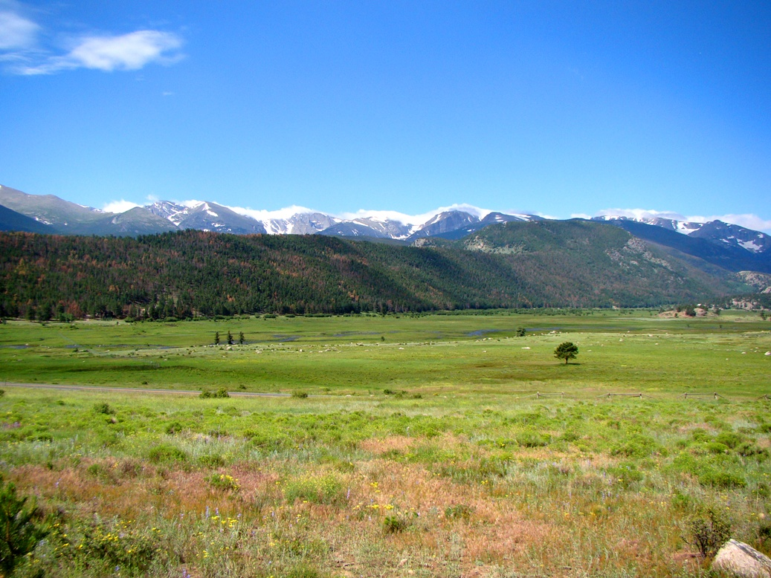  Lateral moraine, Rocky Mountain National Park, USA. (G. Hayes)
Form / Topography | Moraine parallel to ice flow direction.
Environment of Formation | Supraglacial
Process of Formation | Forms from the steady supply of frost shattered debris that falls down onto the glacier from cliffs above where it is abraded between the glacier and the valley side. The communition of the debris accumulated is such that lateral moraines generally have a clay and silt grade dominated matrix. This can give rise to steep inner faces of lateral moraines when the ice recedes rapidly due to the cohesive influence of this fine grained matrix.
Modern Analogue | 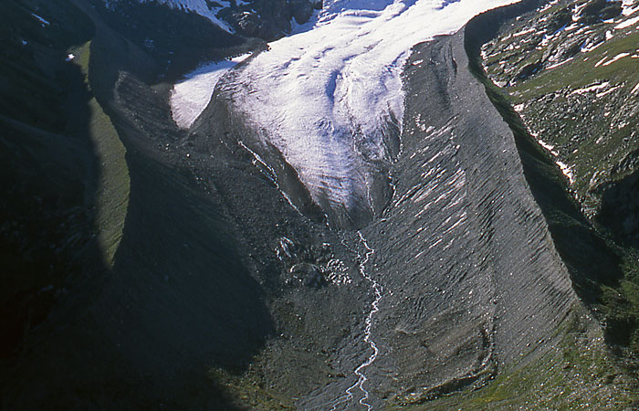  A pair of lateral moraines occurring on both sides of Vadret da Tschierva, Grisons, Switzerland, formed during the Little Ice Age. (J. Alean).
Associated Features
Engineering Significance / Constraints
Principal References | Hambrey, M.J. (1994), Benn, D.I. & Evans, D.J.A. (2010)
Terrain Unit | Medial Moraine
Image | Medial moraine, Denali National Park, Alaska, (J.W. Frank).
Form / Topography | Usually form elevated ridges. Most medial moraines are straight but they can become folded due to compressive flow if the ice spread out laterally as a piedmont glacier. Most medial moraines tend not to be preserved as they contain relatively little debris and are subjected to intense reworking during ice melt. They can be difficult to recognise on the glacier foreground. Debris is angular and frost shattered.
Environment of Formation | Supraglacial
Process of Formation | Ablation results on the concentration of debris on the surface of the glacier. May not appear on the surface until the snout is approached. Debris may be a shallow feature or extend to the base of the glacier.
Modern Analogue | 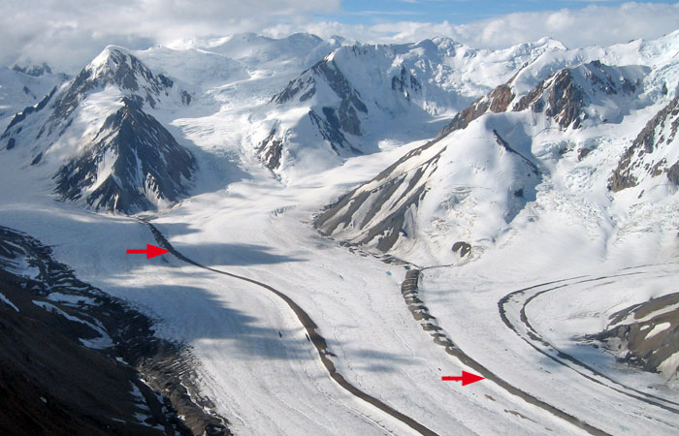  Medial moraines on a tributary of the Kaskawulsh Glacier, Icefield Ranges, Yukon, Canada. (M. J. Hambrey).
Associated Features
Engineering Significance / Constraints
Principal References | Hambrey, M.J. (1994), Benn, D.I. & Evans, D.J.A. (2010), Evans, D.J.A. (2007), Dawson, A.G. (1979)

Terrain Unit | Hummocky Ground Moraine
Image | 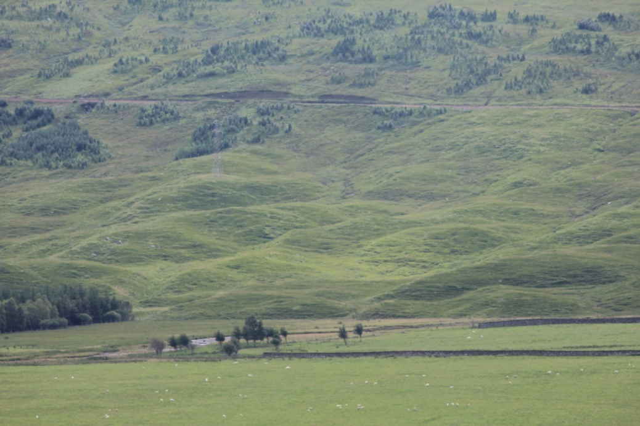  Hummocky ground moraine, Achallader, Scotland (D.Giles)
Form / Topography | Chaotic assemblages of usually steep sided hills formed primarily of ablated supraglacial debris. May be arranged crudely transverse to the valley orientation. A moundy, irregular morainic topography. Both terrestrial and marine forms possible.
Environment of Formation | Supraglacial
Process of Formation | Result from down wastage of ice rather than by ice recession, especially when the ice has ceased to be active. May reflect thrusting processes in the glacier snout. Formed by dead ice wastage processes. Moraines deposited during the meltout of debris mantled ice.
Modern Analogue | 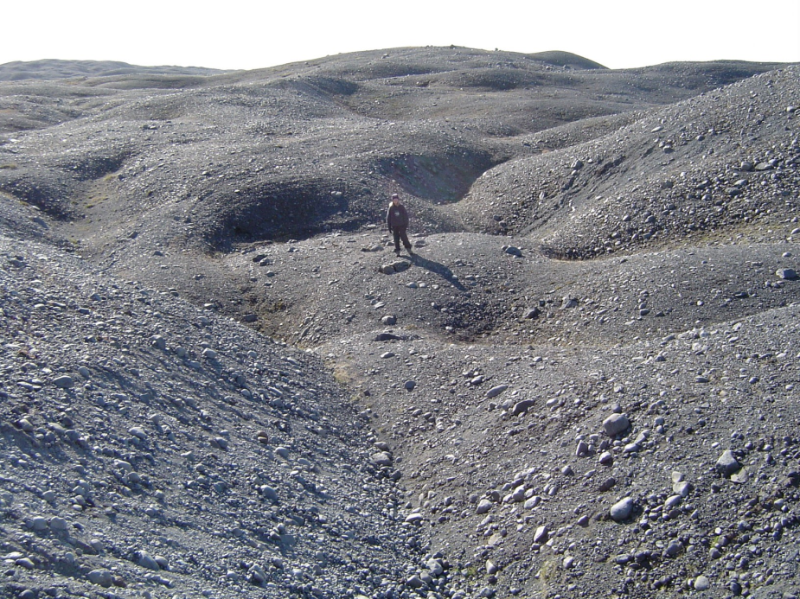  Hummocky moraine, part of the 1890 Brúarjökull end moraine complex, Iceland. (Ó. Ingólfsson).
Associated Features
Engineering Significance / Constraints
Principal References | Evans, D.J.A. (2007), Hambrey, M.J. (1994), Boulton, G.S. (1967)

Terrain Unit | Dump Moraine
Image | 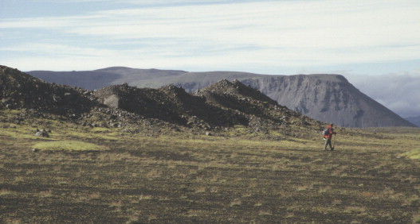  Single-crested dump moraine in front of Kötlujökull in 1997. (J. Krüger et al).
Form / Topography | A dumped mound of glacial debris with a thin veneer of coarse gravel diamicton or sometimes simply a sporadic collection of boulders.
Environment of Formation | Ice marginal
Process of Formation | Form at the margins of debris mantled valley glaciers which occupy similar positions for considerable periods. Material accumulating at the surface of a glacier through the melt out of debris rich ice is ultimately subjected to remobilisation by mass flowage or fluvial transport. Where such material exists at the ice margin its remobilisation may result in it being dumped onto the adjacent terrain during ice recession. Dump moraine will form where the ice margin remains stationary during debris accumulation although they will be bulldozed into push moraine if the ice undergoes a subsequent readvance.
Modern Analogue | 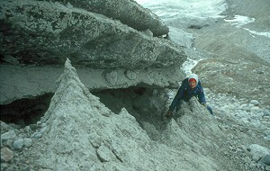  Debris melting out from ice at the edge of the Greenland ice sheet to produce a small "dump" moraine including particle sizes from clay to boulders (P.G. Knight)
Associated Features | Push moraines
Engineering Significance / Constraints
Principal References | Evans, D.J.A. (2007), Krüger, J., et al (2010), Boulton, G.S. & Eyles, N. (1979), Eyles, N. (1979)

Terrain Unit | De Geer (Washboard) Moraine
Image | De Geer Moraines formed about 4000-5000 years ago on north-central Baffin Island, Canada (R. D. Coulthard)
Form / Topography | Succession of discrete narrow ridge ranging from short and straight to long and undulating. Ridges rarely exceed 15m in height; spacing may be up to 300m. Usually composed of till with a cap of boulders and with sand lenses and other stratified waterlain deposits which can include varves (rhythmites) between the ridges.
Environment of Formation | Subglacial. Associated with ? glaciolacustrine and subaqueous environments.
Process of Formation | Origin unclear. May be associated with the accumulation of sediment where the base of the ice detaches from the bed of a lake allowing debris to accumulate as a ramp between well grounded and floating ice. Each ramp ceases to develop when the ice thins sufficiently to break off as an iceberg. Other models suggest that local surging phases of the ice sheet may have led to flexuring of the basal ice zone so as to create basal crevasses. Subaqueous lowering of the ice mass subsequently squeezes the highly saturated sediment which is left as ridges when the ice melts.
Modern Analogue
Associated Features
Engineering Significance / Constraints
Principal References | Evans, D.J.A. (2007), Boulton, G.S. (1986), Hambrey, M.J. (1994), Zilliacus, H. (1989)

Terrain Unit | Esker
Image | 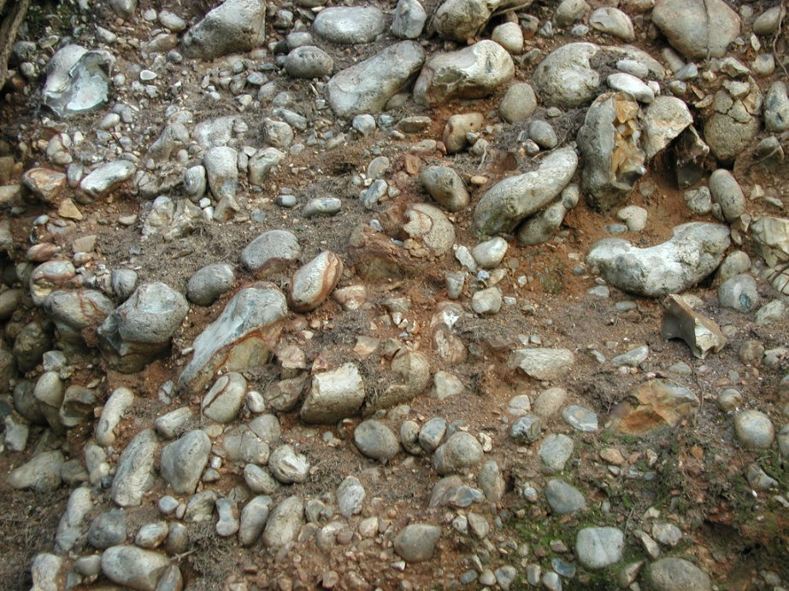  Imbricated clasts in the Blakeney Esker, Norfolk (D. Giles)
Form / Topography | Sinuous elongate ridges of fluvioglacial sands and gravels, usually stratified and imbricated, that can run uphill as well as down. Rarely exceed 700m in width and 50m in height, commonly smaller than this. Clasts tend to be well rounded and sorted.
Environment of Formation | Subglacial
Process of Formation | Formed by deposition from meltwater streams in tunnel systems running perpendicular to the ice front. Process involves the total or partial blocking of subglacial Röthlisberger channels or by infilling of Nye channels cut into the underlying unconsolidated drift or bedrock beneath the ice.
Modern Analogue | 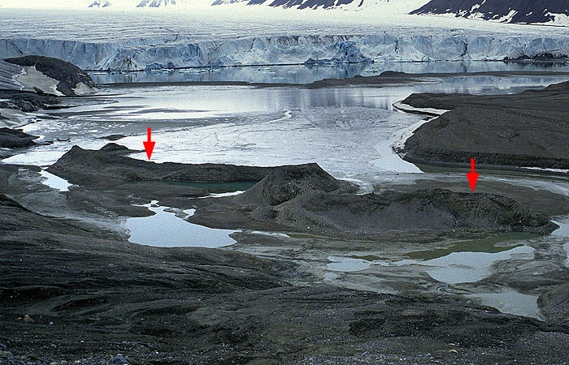  Esker (arrowed) exposed by the receding margin of the glacier Comfortlessbreen (background) in NW Spitsbergen, Svalbard. The ridge is about 3 m high. (M. J. Hambrey)
Associated Features | Kames, Kame Deltas, Sandur
Engineering Significance / Constraints | Significant aggregate resource.
Principal References | Carrivick, J.L. & Russell, A.J. (2007), Hambrey, M. J. (1994), Gray (1997)
Terrain Unit | Kame
Image | 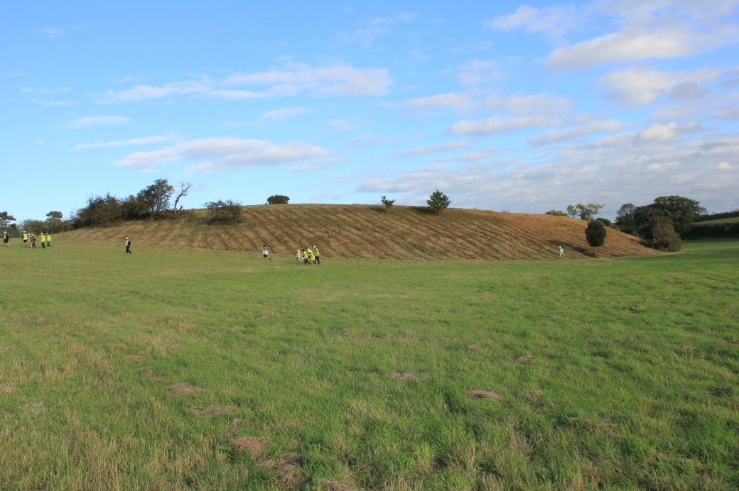  Small kame near Holt, Norfolk. (D. Giles)
Form / Topography | Steep sided hill, usually flat topped, consisting of well sorted stratified sand and gravels. Can experience post depositional modification to varying degrees due to loss of support during ice melt or from compression by ice during an ice advance or by ice over riding the pre-existing kame. Post glacial collapse following the loss of ice support can severely disturb the kame morphology.
Environment of Formation | Ice marginal
Process of Formation | An ice contact fluvioglacial landform deposited by streams adjacent to the ice margin. Associated with supraglacial or ice marginal water. Kame landscapes tend to reflect environments where ice retreat was accompanied by abundant meltwater and sediment supply.
Modern Analogue | 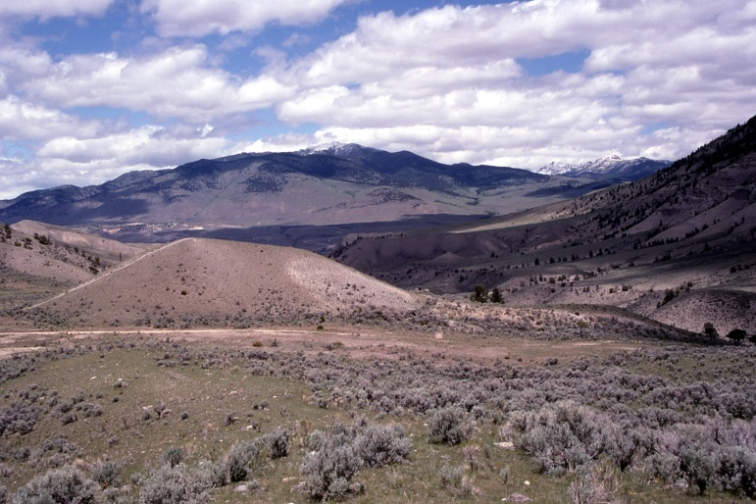  Kame north of Dude Hill, Yellowstone National Park, USA. (J. Suderman).
Associated Features | Kettle Holes, Sandur, Eskers, Kame Terraces, Kame Plateau, Kame Deltas, Kame Fields
Engineering Significance / Constraints
Principal References | Carrivick, J.L. & Russell, A.J. (2007), Knight, P.G. (2009)
Terrain Unit | Sandar (Plural Sandur)
Image | 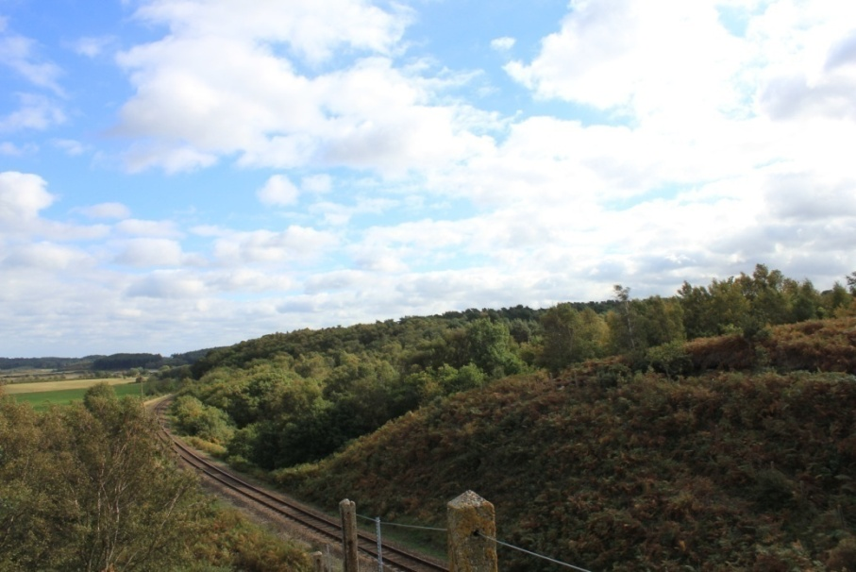  Kelling Heath sandar, near Holt, Norfolk. (D. Giles).
Form / Topography | Laterally extensive outwash plain of fluvioglacial sands and gravels. Typically concave in long profile with a variety of sedimentary forms; cross bedding, bars, scour and channel fill. Bedforms vary in size from 1m to 100m scale. Sediment size will change from the more proximal to distal extremes of the outwash source.
Environment of Formation | Ice marginal, Proglacial Fluvioglacial
Process of Formation | Product of highly variable discharge regime from a sediment rich ice sheet with braided streams of glacial meltwater flowing over them. Can be confined or unconfined. Sedimentation reflects differing seasonal flow rates, flood events and even jökulhlaups. Unconfined sandar occur in coastal or piedmont locations where fluvioglacial sediment aggrades freely without any clear topographic boundary. Where meltwater flows in areas of high relief and is constrained by the local topography then confined sandar are formed, characterised by deeper and higher energy flows giving rise to thicker accumulations of sediment. Sometimes termed valley confined sandar, valley fill sediments or valley train deposits.
Modern Analogue | 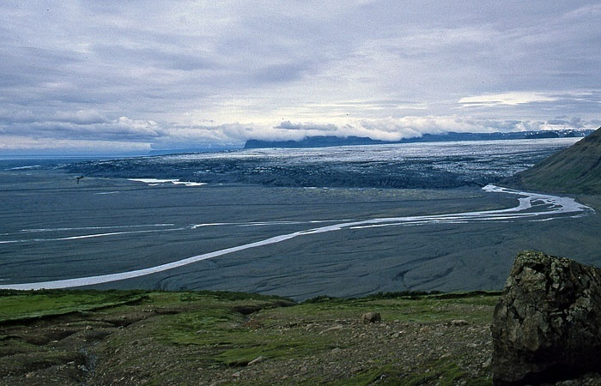  Sandur in southern Iceland, south of Vatnajökull ice cap. (J. Alean).
Associated Features | Eskers, Kames, Kettle Holes
Engineering Significance / Constraints
Principal References | Carrivick, J.L. & Russell, A.J. (2007), Benn, D.I. & Evans, D.J.A. (2010)

Terrain Unit | Kettle (Hole) / Pond
Image | 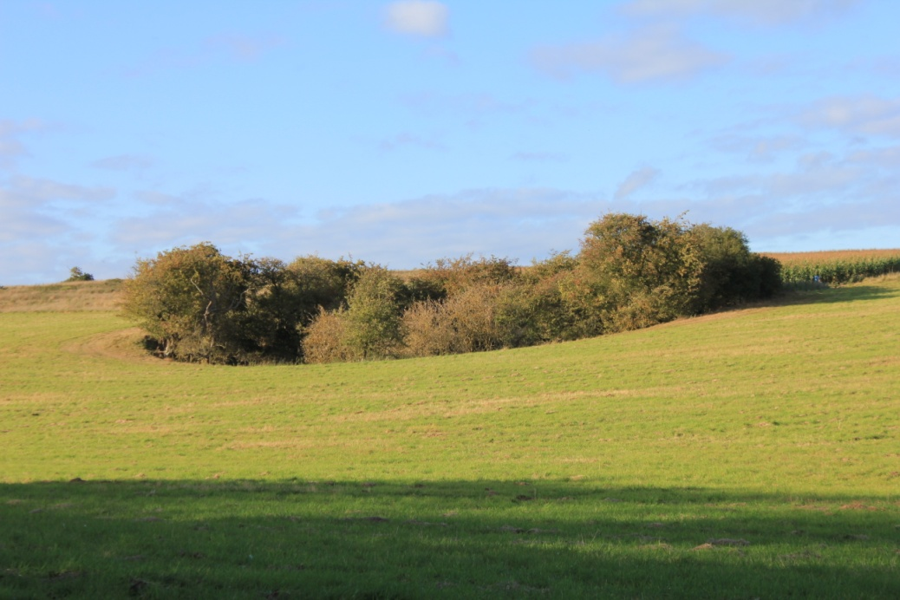  Kettle hole near Holt, Norfolk. (D.Giles)
Form / Topography | A self contained bowl shaped enclosed depression, often containing a pond or soft ground. Kettle holes may become completely infilled with sediment post formation.
Environment of Formation | Ice marginal
Process of Formation | Forms as a result of the burial of a mass of ice by stream sediments and the subsequent melting of the ice that was buried within the sediments.
Modern Analogue | 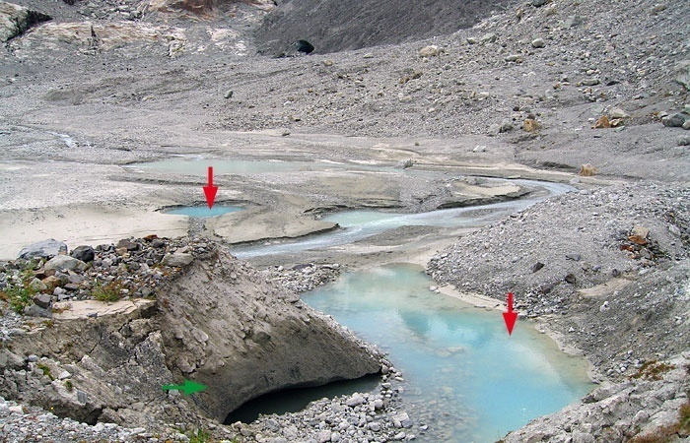  Kettles (red arrows) in the forefield of Glacier du Mont Miné, Valais, Switzerland. Exposed stagnant ice is indicated by the green arrow, and dates from the 1980s advance of this glacier. The debris-covered glacier snout is visible in the centre-background. (M. J. Hambrey).
Associated Features | Kames
Engineering Significance / Constraints
Principal References
Terrain Unit | Relict Frost Mounds / Relict Ramparted Ground-Ice Depressions : Pingos
Image | 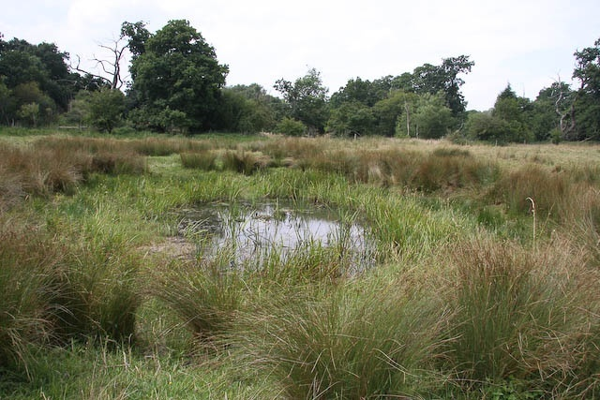  Small pingo remnant near to Thompson, Norfolk, (H. Venables)
Form / Topography | Pingos are ice-cored mounds or hills developed in permafrost. Relict pingos and other ground ice mounds formed during Quaternary cold stages may be indicated by circular or ovate depressions, often surrounded by raised rampart-like rims with a peat or soft ground core. Two forms are identified, closed system (or hydrostatic) pingos and open system (or hydraulic) pingos. The former occur in lowland settings within the continuous permafrost zone, and the latter are more common in valley bottom and footslope localities in both discontinuous and continuous permafrost.
Environment of Formation | Periglacial
Process of Formation | Formed by injection of water into near surface permafrost to form an ice core. Water under sufficient pressure to overcome overburden stress. Pressure can develop in two ways; Closed System where water is expelled from saturated coarse grained sediments during the refreezing of a talik (a zone of unfrozen sediment within a continuous permafrost) or Open System where artesian water pressures within a sub permafrost aquifer cause upward injection and freezing of water.
Modern Analogue | 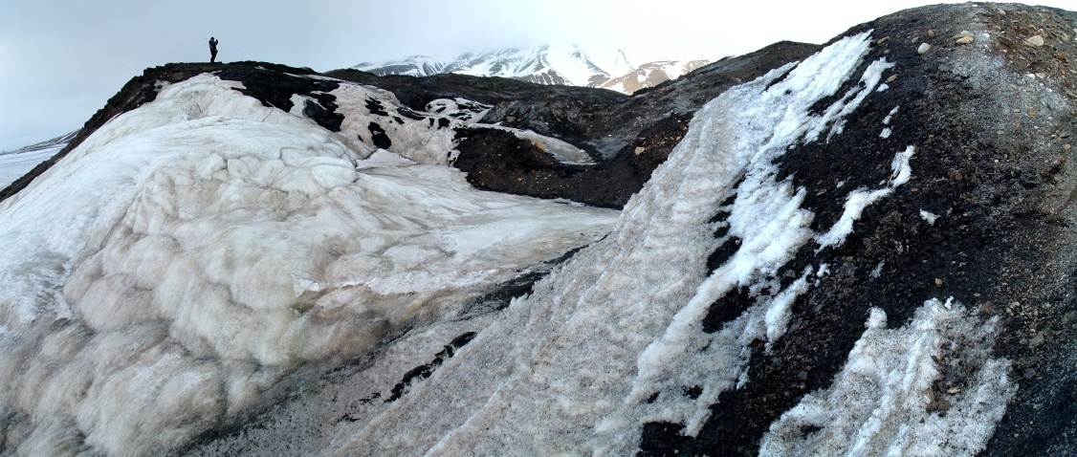  Active Pingo, Innerhytte, Svalbard, (P. Brabham).
Associated Features | Related smaller ground ice phenomena associated with permafrost regions are lithalsas, mineral palsas, and seasonal ground ice mounds.
Engineering Significance / Constraints
Principal References | Harris, C. & Ross, N. (2007), Hutchinson, J.N. (1980, 1991, 1992)

Terrain Unit | Superficial Valley Disturbances
Image | 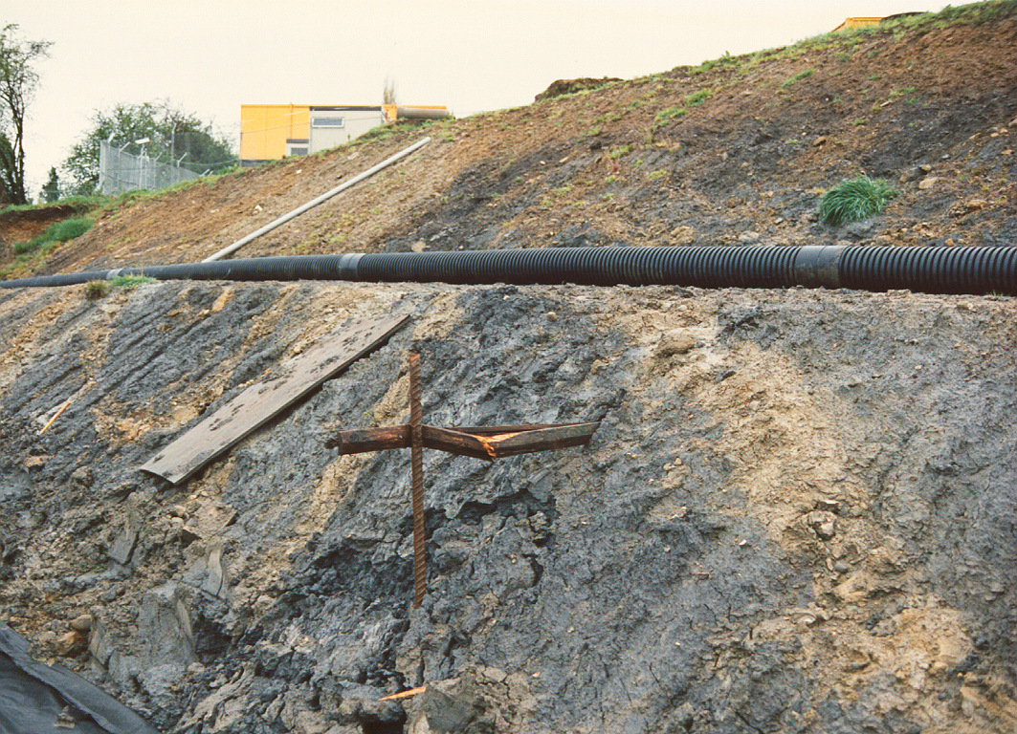  A46 Batheaston Bypass. (D.Giles)
Form / Topography
Environment of Formation | Periglacial
Process of Formation | Displacements resulting from stress relief accompanying the formation of all valleys.
Modern Analogue | 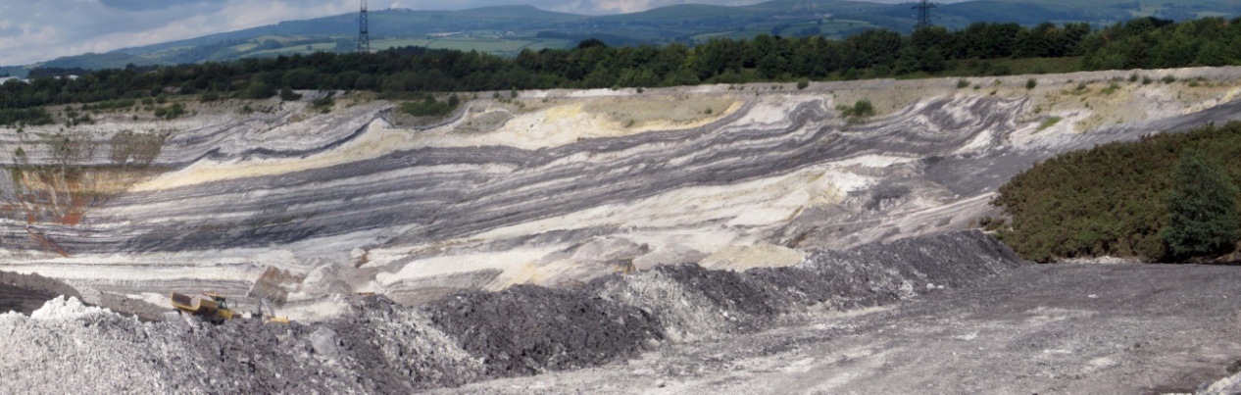  Superficial valley disturbances, Newbridge Ball Clay Quarry. (K. Privett).
Associated Features | Cambering, gulls, Dip and Fault structures
Engineering Significance / Constraints
Principal References | Parks, C.D. (1991), Hutchinson, J.N. (1991, 1992), Higginbottom, I.E. & Fookes, P.G. (1970), Horswill P. & Horton A. (1976)

Terrain Unit | Cambering
Image
Form / Topography
Environment of Formation | Periglacial
Process of Formation
Modern Analogue
Associated Features | Superficial valley disturbances, gulls, Dip and Fault structures
Engineering Significance / Constraints
Principal References | Parks, C.D. (1991), Hutchinson, J.N. (1991, 1992), Higginbottom, I.E. & Fookes, P.G. (1970), Horswill P. & Horton A. (1976), Hawkins A.B. & Privett K.D. (1981)

Terrain Unit | Dip and Fault Structures
Image
Form / Topography
Environment of Formation | Periglacial
Process of Formation
Modern Analogue
Associated Features | Cambering, Superficial valley disturbances, gulls
Engineering Significance / Constraints
Principal References | Parks, C.D. (1991), Hutchinson, J.N. (1991, 1992), Higginbottom, I.E. & Fookes, P.G. (1970), Horswill P. & Horton A. (1976), Hawkins A.B. & Privett K.D. (1981)

Terrain Unit | Gulls
Image | 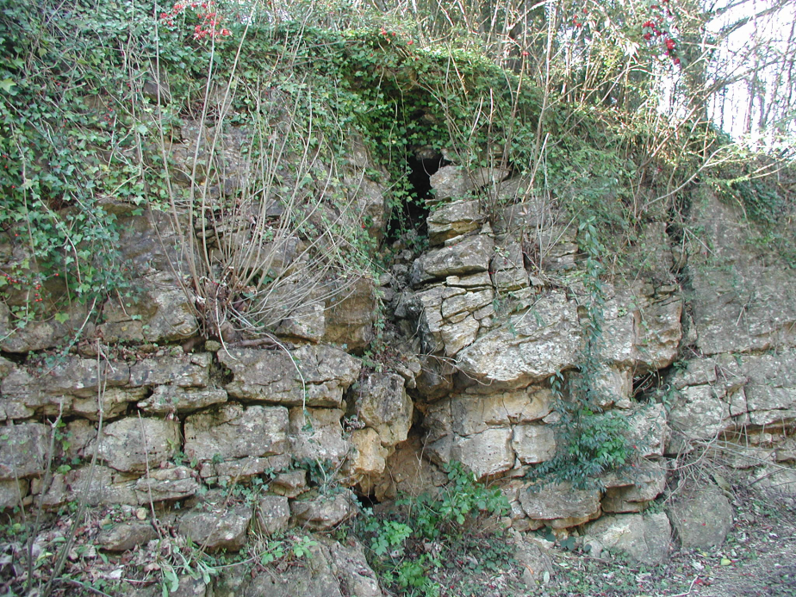  Gulls in Jurassic Oolitic Limestone, Quarry Road, University of Bath. (D. Giles).
Form / Topography
Environment of Formation | Periglacial
Process of Formation
Modern Analogue
Associated Features
Engineering Significance / Constraints
Principal References | Parks, C.D. (1991), Hutchinson, J.N. (1991, 1992), Higginbottom, I.E. & Fookes, P.G. (1970), Horswill P. & Horton A. (1976), Hawkins A.B. & Privett K.D. (1981)

References

References JG

Addison, 1983
Ballantyne, 2002
Ballantyne & Harris, 1994
Boulton & Paul, 1976
Brikzikowski & Van Loon, 1987
Brunsden 2002
Brunsden et al, 1976
Bűdel, xxx
Chorley & Kennedy 1971
Chorley, Schumm & Sugden 1984
Christian & Stewart, 1953
Clark & Johnson, 1976
Derbyshire et al 1979
Evans, 2007
Evans, 2011
Eyles et al 1987
Eyles & Eyles, 1992
Flint, 1971
Fookes et al, 2007
Griffiths J S, 2004. Terrain Evaluation. Definition in A. S. Goudie (ed.) Encyclopedia of Geomorphology, Routledge, London, 1044-1049.
Griffiths J S & Edwards R J G, 2001. The development of land surface evaluation for engineering practice. In J S Griffiths (ed.), Land Surface Evaluation for Engineering Practice, Engineering Geology Special Publication, 18, Geological Society, London, 3-9.
Griffiths et al ,1994
Fookes 1997
Hearn ,2012
Higginbottom & Fookes, 1976
Huggett, 2007
Ingolfsson, 2011
Karte, 1979
Lawrance, C. J., Byard, R. J., and Beaven, P. J. (1993). Terrain Evaluation Manual. Transport Research Laboratory, State of the Art Review 7, HMSO, London.
Lonne & Nemec, 2011
Lowe & Walker, 1997
Mitchell. C.W. (1973). Terrain Evaluation. Longmans; London.
Ottesen & Dowdeswell, 2009
Owen & Derbyshire, 2005
Parry, 2012
Phipps, 2001
Shaw, 1971
Shilston et al, 2011
Smith et al, 2011
Smithson, et al, 2002
Thorp, 1986
Tricart, xxxx
Sugden & John, 1976
Walker 2005
Waller & Phipps 1996
Whiteman, 1996
Williams & Smith, 1989

References DPG

Benn, D.I. & Evans, D.J.A. (2010) Glaciers and Glaciation. 2nd Edition. Hodder Education Oxford.

Boulton, G.S. (1967) The development of a complex supraglacial moraine at the margin of Sørbreen, Ny Friesland, Vestspitsbergen. Journal of Glaciology, 6 (47), 717-735

Boulton, G.S. (1986) Push-moraines and glacier-contact fans in marine and terrestrial environments. Sedimentology, 33 (5), 677–698. doi: 0.1111/j.1365-3091.1986.tb01969.x

Boulton, G.S. & Eyles, N. (1979) Sedimentation by valley glaciers: A model and genetic classification. In Schluchter, C. (Ed.) Moraines and Varves, 11-23. Balkema.

Carrivick, J.L. & Russell, A.J. (2007) Glaciofluvial landforms of deposition. In In: Elias, S.A. (Ed.) Encyclopedia of Quaternary Science, 909-920, Elsevier. doi:10.1016/B0-44-452747-8/00087-9

Croot, D. & Griffiths, J.S. (2001) Engineering geological significance of relict periglacial activity in South and East Devon. Quarterly Journal of Engineering Geology and Hydrogeology, 269-281. doi:10.1144/qjegh.34.3.269

Dawson, A.G. (1979) A Devensian Medial Moraine in Jura. Scottish Journal of Geology, 15, 43-48. doi:10.1144/sjg15010043

Evans, D.J.A. (2007) Glacial landforms: Moraine forms and genesis. In: Elias, S.A. (Ed.) Encyclopedia of Quaternary Science, 772-784. Elsevier. doi: 10.1016/B0-44-452747-8/00086-7

Eyles, N. (1979) Facies of Supraglacial sedimentation on Icelandic and Alpine temperate glaciers. Canadian Journal of Earth Science, 16 (7), 1341-1361. doi: 10.1139/e79-121

Gray, J.M. (1997) The origin of the Blakeney Esker, Norfolk. Proceedings of the Geologists' Association, 108 (3), 177–182. doi: 10.1016/S0016-7878(97)80025-9

Hambrey, M.J. (1994) Glacial Environments. UCL Press, London.

Harris, C. & Ross, N. (2007) Periglacial Landforms: Pingos and Pingo Scars. In: Elias, S.A. (Ed.) Encyclopedia of Quaternary Science, 2200-2207. Elsevier. doi: 10.1016/B0-44-452747-8/00106-X

Hawkins A.B. & Privett K.D. (1981) A building site on cambered ground at Radstock, Avon. Quarterly Journal of Engineering Geology, 14,151–167 doi:10.1144/GSL.QJEG.1981.014.03.02

Higginbottom, I.E. & Fookes, P.G. (1970) Engineering aspects of periglacial features in Britain. Quarterly Journal of Engineering Geology and Hydrogeology, 85-117, doi:10.1144/GSL.QJEG.1970.003.02.02

Horswill P., Horton A. & Penman D.M. (1976) Cambering and Valley bulging in the Gwash Valley at Empingham, Rutland. Philosophical Transactions of the Royal Society, A283, 427–462. doi: 10.1098/rsta.1976.0092

Hutchinson, J.N. (1980) Possible late Quaternary pingo remnants in central London. Nature, 284, 253 – 255. doi:10.1038/284253a0

Hutchinson, J.N. (1991) Periglacial and slope processes. In: Forster, A., Culshaw, M.G., Cripps, J.C. & Moon, C.F. (Eds.) Quaternary Engineering Geology, Geological Society Engineering Geology Special Publication No. 7, 283-331. doi:10.1144/GSL.ENG.1991.007.01.27

Hutchinson, J.N. (1992) Engineering in relict periglacial and extraglacial areas in Britain. In: Gray, J.M. (Ed.) Applications of Quaternary Research, Quaternary Proceedings No. 2. Quaternary Research Association, Cambridge, 49-65.

Knight, P.G. (2009) Kames. In: Gornitz, V. (Ed.) Encyclopedia of Paleoclimatology and Ancient Environments, 483-484. Springer. doi: 10.1007/978-1-4020-4411-3_118

Krüger, J., Schomacker, A. & Benediktsson, I.O. (2010) Ice-marginal environments: geomorphic and structural genesis of marginal moraines at Mýrdalsjökull, In: Schomacker, A., Krüger, J. and Kjær, K.H. (Eds.) Developments in Quaternary Sciences, 13, 79-104., Elsevier. doi: 10.1016/S1571-0866(09)01306-2

Morgan, A.V. (1971) Engineering problems caused by fossil permafrost features in the English Midlands. Quarterly Journal of Engineering Geology and Hydrogeology, 111-114, doi:10.1144/GSL.QJEG.1971.004.02.02

Murton, J. (2007) Periglacial Landforms: Ice Wedges and Ice Wedge Casts. In: Elias, S.A. (Ed.) Encyclopedia of Quaternary Science, 2153–2170. Elsevier. doi: 10.1016/B0-44-452747-8/00108-3

Parks, C.D. (1991) A review of the mechanisms of cambering and valley bulging. In: Forster, A., Culshaw, M.G., Cripps, J.C. & Moon, C.F. (Eds.) Quaternary Engineering Geology, Geological Society Engineering Geology Special Publication No. 7, 373-380. doi:10.1144/GSL.ENG.1991.007.01.33

Zilliacus, H., (1989) Genesis of De Geer moraines in Finland. Sedimentary Geology, 62, 309-317. doi: 10.1016/0037-0738(89)90121-8

Terrain Unit Descriptors (for each element / facet as detailed above)

Terrain Unit | Feature name from defined list.
Image | Relict form as aid to field recognition. Engineers need to understand the modern analogue but more significantly need to recognise the relict form. 8cm high
Form / Topography | Diagnostic characteristics for field recognition.
Environment of Formation | To link to Dave Evans ground models.
Process of Formation | Brief details of the key glacial/periglacial processes involved.
Modern Analogue | Examples of where features or processes can be observed today. 8cm high
Associated Features | Other features that could be expected to be present.
Engineering Significance / Constraints | Significance to geomaterials, slope stability, foundations, variable ground etc – simple warning and awareness statements.
Principal References | List of key definitive references for feature.

Table 3.1 Types of Ground Model (after Parry, 2012)
Model Type | Sub categories | Description | Reference example
Conceptual  that are essentially qualitative in nature and illustrate the key features of a geological situation and the processes active in that environment | Generalised | Models that do not represent any specific location but constitute an amalgamation comprising the features and associated geomorphological processes
 | Site Specific | Use the same approach as generalised models but refer to specific locations and draw on site specific data
 | Evolutionary | Can be quite generalised and used to illustrate the way a site may have evolved over time However, they may also be site specific in which case the can overlap with observational models | (Baynes et al. 2005).
Observational.  Scaled down versions of actual ground conditions at specific sites | Site Specific | These represent the interpretation of actual data collected from all sources and are the most useful for supporting geotechnical engineers in the detailed design of foundations and earthworks | Parry, 2011; Baynes et al 2005: Fookes, 1997)
 | Physical | Originally this was envisaged as a physical construct using plaster, paper mâché etc. However, the modern equivalent would be a computer generated virtual reality model
Analytical Representations of reality using mathematical formulae, different media or schematics | Mathematical | Interrelationships between components of the model are represented by mathematical formulae. These can be deterministic where actual physics formulae are used, or stochastic where the relationships are expressed in statistical or probabilistic terms
 | Schematic | Diagram that identifies the inter-relationships between components of a natural system
 | Analogue | Represents reality using different media such as the classic geological models of brittle, plastic and visco-plastic behaviour rocks using springs

Table 3.2 Classification of principal, sediment facies found in continental ice-marginal zones (illustrated in Figures 3.13 and 3.14) according to Brodzikowski & Van Loon (1987).

GLACIAL ENVIRONMENT |  |  | EXTRAGLACIAL ENVIRONMENT
I-A | Supraglacial Subenvironment |  | II-A | Terminoglacial Subenvironment
I-A-1 | Supraglacial melting ice facies |  | II-A-1 | Terminoglacial lacustrine facies
 | I-A-1-a | supraglacial flow-tills |  | II-A-1-a | terminoglacial lacustrine deposits
 | I-A-1-b | supraglacial ablation tills |  | II-A-1-b | terminoglacial subaqueous mass-flow deposits
 |  |  |  | II-A-1-c | terminoglacial tunnel-mouth deposits
I-A-2 | Supraglacial crevasse facies
 | I-A-2-a | supraglacial crevasse deposits | II-A-2 | Terminoglacial fluvial facies
 | I-A-2-b | supraglacial stream deposits |  | II-A-2-a | terminoglacial tunnel-mouth deposits
I-A-3 | Supraglacial fluvial facies |  | II-A-3 | Terminoglacial terrestrial facies
 | I-A-3-a | supraglacial stream deposits |  | II-A-3-a | terminoglacial subaerial mass-flow deposits
 | I-A-3-b | supraglacial stream deposits
 |  |  | II-B | Near-terminus Subenvironment
I-A-4 | Supraglacial deltaic facies |  | II-B-1 | Near-terminus fan facies
 | I-A-4-a | supraglacial stream deposits |  | II-B-1-a | near-terminus subaerial mass-flow deposits
 | I-A-4-b | supraglacial deltaic deposits |  | II-B-1-b | near-terminus stream-flood and sheet-flood deposits
 | I-A-4c | supraglacial bottom-sets |  | II-B-1-c | near-terminus fluvial deposits
I-A-5 | Supraglacial Iacustrine facies
 | I-A-5-a | supraglacial bottom-sets
 | I-A-5-b | supraglacial lake-margin deposits

I-B | Englacial Subenvironment |  | II-B-2 | Near-terminus deltaic facies
I-B-1 | Englacial melting-ice facies |  |  | II-B-2-a | near-terminus fluvial deposits
 | I-B-1-a | englacial melt-out tills |  | II-B-2-b | near-terminus deltaic foresets
 |  |  |  | II-B-2-c | near-terminus bottom-sets
I-B-2 | Englacial crevasse facies
 | I-B-2-a | englacial crevasse deposits | II-B-3 | Near-terminus lacustrine facies
 |  |  |  | II-B-3-a | near-terminus bottom-sets
I-B-3 | Meltwater-tunnel facies |  |  | II-B-3-b | near-terminus lake margin deposits
 | I-B-3-a | Englacial crevasse deposits
 |  |  | II-C | Extraglacial Subenvironment
I-C | Subglacial Subenvironment |  | II-C-1 | Extraglacial aeolian facies
 |  |  |  | II-C-1-a | drift sands
I-C-1 | Meltwater-tunnel facies |  |  | II-C-1-b | coversands
 | I-C-1-a | subglacial channel deposits |  | II-C-1-c | loess
I-C-2 | Subglacial lacustrine facies
 | I-C-2-a | subglacial channel deposits
 | I-C-2-b | subglacial lacustrine deposits
I-C-3 | Subglacial melting-ice facies
 | I-C-3-a | subglacial lacustrine deposits
 | I-C-3-b | lodgement tills
 | I-C-3-c | basal tills

